Student Name : CHALLA RAVITEJA
Register Number : 192325065

CO1_AT1
MLA0201 – FUNDAMENTALS OF MACHINE LEARNING LAB PROGRAMS
Application – Based Questions

PROGRAM 1:
AIM:
Implement the concept of probability distribution to predict the likely root of spam emails in a mail filtering system.

CONCEPT: Spam Email Prediction Using Probability Distribution
Probability distribution describes the likelihood of different possible outcomes of an event. In an email filtering system, emails can be classified into outcomes such as Spam and Not Spam based on their probabilities. The occurrence of certain words, such as “free,” can provide additional evidence for classification. By calculating prior probabilities and conditional probabilities, a probability-based score is obtained for each class. The class with the higher score is selected as the predicted result. This demonstrates how probability can support decision-making under uncertainty.

PROGRAM:
# Total number of emails
total_emails = int(input("Enter the Total Mails count:"))

# Number of spam and non-spam emails
spam_emails = int(input("Enter the Total Spam Mails:"))
not_spam_emails = int(input("Enter the Total Not Spam Mails: "))

# Calculate probability of spam and not spam
p_spam = spam_emails / total_emails
p_not_spam = not_spam_emails / total_emails

# Emails containing the word "free"
free_in_spam = 5
free_in_not_spam = 1

# Probability of finding "free"
p_free_given_spam = free_in_spam / spam_emails
p_free_given_not_spam = free_in_not_spam / not_spam_emails

# Calculate spam and not spam scores
spam_score = p_spam * p_free_given_spam
not_spam_score = p_not_spam * p_free_given_not_spam
print("Spam Score:", spam_score)
print("Not Spam Score:", not_spam_score)

# Predict the email
if spam_score > not_spam_score:
print("Prediction: SPAM EMAIL")
else:
print("Prediction: NOT SPAM EMAIL")

OUTPUT:

PROGRAM 2:
AIM:
Illustrate how bayes theory can be apply medical daiognissis for diseas prediction

CONCEPT: Medical Diagnosis Using Bayes’ Theorem
Bayes’ Theorem is a probability technique used to update the likelihood of an event when new evidence becomes available. In medical diagnosis, the initial probability of having a disease is called the prior probability. When a patient receives a positive test result, this new evidence is combined with the test sensitivity and false-positive probability. Bayes’ Theorem then calculates the updated probability of having the disease given the positive result, written as P(Disease | Positive). This concept is useful for understanding how diagnostic evidence changes disease probability.

PROGRAM:
# Probability that a person has the disease
p_disease = 0.01

# Probability that a person does not have the disease
p_no_disease = 1 - p_disease

# Probability of positive test if disease is present
p_positive_given_disease = 0.90

# Probability of positive test if disease is not present
p_positive_given_no_disease = 0.05

# Calculate total probability of a positive test
p_positive = ( p_positive_given_disease * p_disease + p_positive_given_no_disease * p_no_disease)

# Apply Bayes' Theorem
p_disease_given_positive = (p_positive_given_disease * p_disease) / p_positive

# Display result
print("Probability of Disease given Positive Test:", p_disease_given_positive)
print("Percentage:", p_disease_given_positive * 100, "%")

# Prediction
if p_disease_given_positive > 0.5:
print("Prediction: HIGH POSSIBILITY OF DISEASE")
else:
print("Prediction: LOW POSSIBILITY OF DISEASE")

OUTPUT:

PROGRAM 4:

AIM:
Model the weather forecasting system with its outcome and challenges using random variables and probability theory.

CONCEPT: Weather Forecasting Using Random Variables and Probability Theory
Weather forecasting involves uncertainty because future weather conditions cannot be predicted with complete certainty. A random variable can represent possible weather outcomes such as Sunny, Rainy, and Cloudy, while a probability distribution assigns a likelihood to each outcome. Based on historical observations or assumed probabilities, the system can identify the most likely weather condition or simulate possible outcomes. The sum of probabilities of all possible outcomes must equal 1. Real weather forecasting is challenging because conditions change continuously and depend on many interacting factors such as temperature, humidity, wind, and atmospheric pressure.

PROGRAM:
import numpy as np
# Step 1: Define possible weather outcomes
weather = ["Sunny", "Rainy", "Cloudy"]

# Step 2: Assign probabilities to each outcome
probabilities = [0.5, 0.3, 0.2]

# Step 3: Predict weather using probability
predicted_weather = np.random.choice(weather, p=probabilities)
print("Possible Weather Outcomes:", weather)
print("Probabilities:", probabilities)
print("\nPredicted Weather:", predicted_weather)

# Step 4: Find the most likely weather
most_likely_weather = weather[np.argmax(probabilities)]
print("Most Likely Weather:", most_likely_weather)

# Step 5: Display challenges
print("\nChallenges in Weather Forecasting:")
print("1. Weather conditions change quickly.")
print("2. Forecasts depend on accurate historical data.")
print("3. Probability does not guarantee an exact outcome.")
print("4. Many factors affect weather prediction.")

OUTPUT:
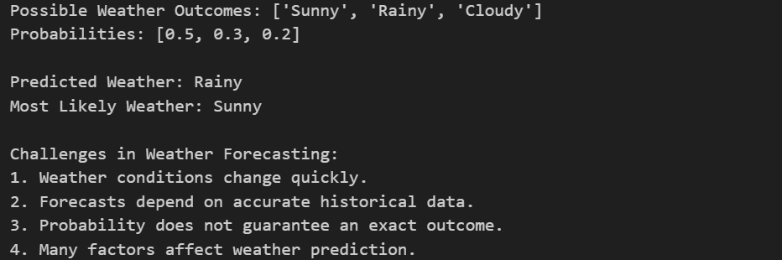

PROGRAM 6:
AIM:
Apply conditional probability concepts to desing a fraud detection model for suspecious banking transaction.

CONCEPT: Fraud Detection Using Conditional Probability
Conditional probability determines the likelihood of an event based on the occurrence of another related event. In banking fraud detection, historical transactions can be categorized as Fraud or Normal, and suspicious behavior is treated as evidence. The system calculates probabilities such as P(Suspicious | Fraud) and uses them to estimate P(Fraud | Suspicious). This helps determine how likely a suspicious transaction is to actually be fraudulent. A probability threshold can then be used to classify the transaction or flag it for further investigation.

PROGRAM:

# Total number of transactions
total_transactions = 1000

# Fraud and normal transactions
fraud_transactions = 100
normal_transactions = 900

# Suspicious transactions in each category
suspicious_fraud = 80
suspicious_normal = 90

# Step 1: Calculate prior probabilities
p_fraud = fraud_transactions / total_transactions
p_normal = normal_transactions / total_transactions

# Step 2: Calculate conditional probabilities
p_suspicious_given_fraud = suspicious_fraud / fraud_transactions
p_suspicious_given_normal = suspicious_normal / normal_transactions

# Step 3: Calculate total probability of a suspicious transaction
p_suspicious = ( p_suspicious_given_fraud * p_fraud + p_suspicious_given_normal * p_normal)

# Step 4: Calculate probability of fraud given suspicious
p_fraud_given_suspicious = (
p_suspicious_given_fraud * p_fraud
) / p_suspicious

# Display the probability
print("Probability of Fraud:", p_fraud)

print("Probability of Suspicious given Fraud:", p_suspicious_given_fraud)
print("Probability of Fraud given Suspicious:", p_fraud_given_suspicious)

# Step 5: Fraud detection decision
if p_fraud_given_suspicious > 0.5:
print("Prediction: FRAUD TRANSACTION")
else:
print("Prediction: NORMAL TRANSACTION")

OUTPUT:
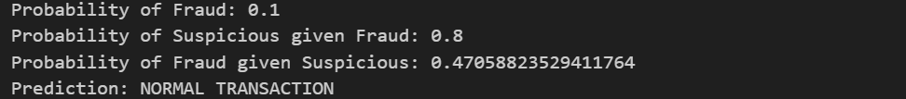

PROGRAM 8:
AIM:
Consturct a machine learning workflow by applying workflow by applying stages of the system.

CONCEPT: Machine Learning Workflow
A Machine Learning workflow is a sequence of stages followed to develop a predictive system. It begins with data collection and preparation, followed by selecting relevant input features and the target variable. The dataset is divided into training and testing sets so that the model can learn from one portion and be evaluated on unseen data. A suitable algorithm, such as a Decision Tree Classifier, is trained using the training data and evaluated using metrics such as accuracy. Once evaluated, the trained model can be used to make predictions for new data. This workflow provides a systematic approach for developing and testing Machine Learning solutions.

PROGRAM:

import pandas as pd
from sklearn.model_selection import train_test_split
from sklearn.tree import DecisionTreeClassifier
from sklearn.metrics import accuracy_score

# Stage 1: Data Collection
data = {
"Study_Hours": [2, 5, 7, 1, 6, 3, 8, 4, 2, 7],
"Attendance": [50, 75, 85, 40, 80, 60, 90, 70, 55, 88],
"Result": [
"Fail", "Pass", "Pass", "Fail", "Pass",
"Fail", "Pass", "Pass", "Fail", "Pass"
]
}

df = pd.DataFrame(data)
print("Student Dataset:")
print(df)

# Stage 2: Select Features and Target
X = df[["Study_Hours", "Attendance"]]
y = df["Result"]

# Stage 3: Split Data into Training and Testing
X_train, X_test, y_train, y_test = train_test_split(
X,
y,
test_size=0.2,
random_state=42
)

# Stage 4: Select the Machine Learning Model
model = DecisionTreeClassifier(random_state=42)

# Stage 5: Train the Model
model.fit(X_train, y_train)

# Stage 6: Test the Model
y_pred = model.predict(X_test)

# Stage 7: Evaluate the Model
accuracy = accuracy_score(y_test, y_pred)
print("\nActual Results:", list(y_test))
print("Predicted Results:", list(y_pred))
print("Model Accuracy:", accuracy)

# Stage 8: Predict New Data
new_student = pd.DataFrame( [[6, 82]], columns=["Study_Hours", "Attendance"])
prediction = model.predict(new_student)
print("\nNew Student:")
print("Study Hours: 6")
print("Attendance: 82%")
print("Predicted Result:", prediction[0])

OUTPUT:
